# Apply filters to SQL queries

## Project description

The organization has tasked me with making the system more secure. The following screenshots and descriptions are ways I investigated the problems found within the database. I used SQL to retrieve the login details and data so the organization can know how to best handle these security concerns.

## Retrieve after hours failed login attempts

The following SQL statements show how I created a query to find fail login attempts after business hours.

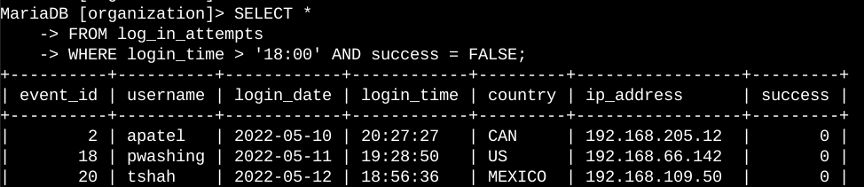

First, I began by selecting all data from the log_in_attempts table. Then I used the WHERE statement and the AND operator to filter the login attempts that failed after business hours at 6 P.M. Or 18:00. The success column being populated with 0’s indicated the boolean logic of “false”.

## Retrieve login attempts on specific dates

The following SQL statements show how I created a query to filter login attempts on a specific date.

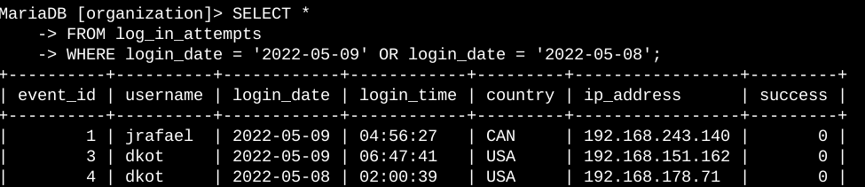

First I began by selecting all the data from log_in_attempts once again. Then I used the WHERE statement with the OR operator to filter the login attempts to a certain date range (2022-05-08 - 2022-05-09)..

## Retrieve login attempts outside of Mexico

The following SQL statements show how I created a query to fitler login attempts that were made outside of Mexico.

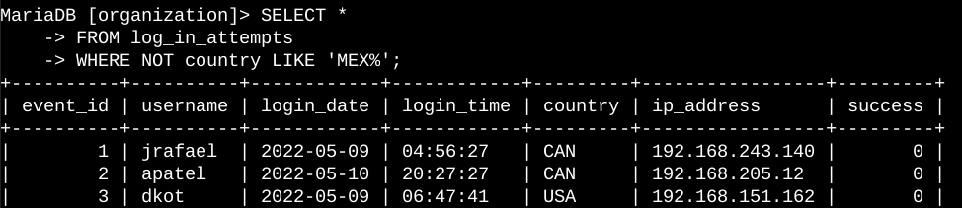

First I began by selecting all the data from log_in_attempts once again. Then I used the WHERE statement and the LIKE operator to filter the login attempts that were made outside of Mexico. The ‘MEX%’ portion of the LIKE operator is the pattern to match the word Mexico because MEX is found within Mexico.

## Retrieve employees in Marketing

The following SQL statements show I created a query to filiter employee machines from the employee table in the Marketing department in the East building.

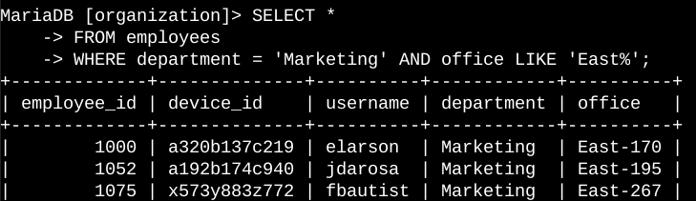

This query returns all employees in the marketing department in the east building. First I began by selecting all the data in the employees table. Then I used the WHERE statement and the AND operator with the ‘EAST%’ suffix to filter the employees.

## Retrieve employees in Finance or Sales

The following SQL statements show how I created a query to filter for employee machines from the Finance or Sales department.

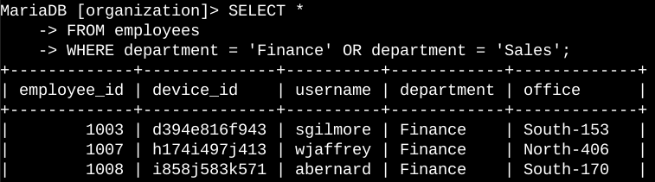

First I selected all the data from the employees table. Then I used the WHERE statement and the OR operator to filter the data for all employees who work in the Finance department and the Sales department.

## Retrieve all employees not in IT

The following SQL statements show how I created a query to filter for employee machines from employees that are not in the Information Technology department.

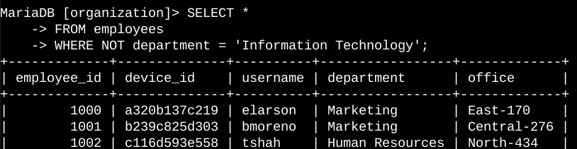

First I selected all the data from the employees table. Then I used the WHERE NOT statement to filter the data to show all employees from the Information Technology department. Since the WHERE NOT statement was used, it excluded all departments except for the Information Technology department.

## Summary

I used SQL statements to get specific data from login attempts and employee machines. I used the log_in_attempts and employees tables. I also used the AND, OR, and NOT operators to refine the query. The LIKE and % suffixes were used as well to help refine the search parameters.